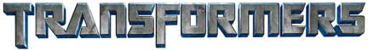
Character Bios of the Autobots® and Decepticons®

AUTOBOTS®: The “good guys” in the TRANSFORMERS race. AUTOBOTS® hold to the ideals of defending life and aspire to a peaceful existence.

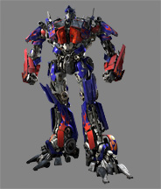  OPTIMUS PRIME® | 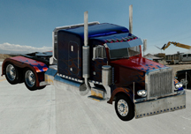  18-WHEELER TRACTOR

OPTIMUS PRIME®is the leader of the AUTOBOTS®. Voiced by Peter Cullen in both the original animated series and DreamWorks Pictures’ and Paramount Pictures’ “TRANSFORMERS. Many years ago, the Matrix of Leadership — a physical piece that Optimus wears inside his chest cavity, the Matrix of Leadership is the “crown” carried by each Prime — “chose” him to be the next Prime, or leader. He humbly accepted, which changed the course of his life from simple working class ‘bot on Cybertron to leader of the strongest benevolent force in the Universe, the Autobots®. When leading his team into battle, Optimus Prime’s signature phrase is “Transform and Rollout!”

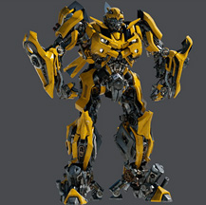  BUMBLEBEE™ | 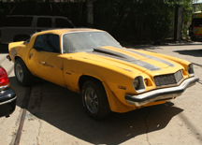  CLASSIC CAMARO®

BUMBLEBEE™ was one of the Autobots® on the Ark when it crashed into Earth and was involved in many battles, and also served as a useful Autobot® spy. In “TRANSFORMERS,” he is Sam Witwicky’s first car, a Classic Camaro. Bumblebee’s function is espionage and reconnaissance missions. He is the “little brother” in the Autobot family, acting as the scout who makes his way boldly into dangerous missions.

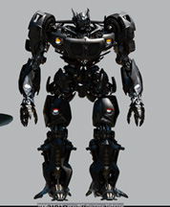  AUTOBOT JAZZ® |   PONTIAC® SOLSTICE®

AUTOBOT JAZZ® remains one of the best-loved characters from the original series. He lives by the “rock ‘n roll” lifestyle credo of “if you can’t do something with style, it’s not worth doing at all.” He is very cool, stylish, and competent. He is daring and clever. He has near-perfect recordable memory that makes him invaluable as a documenter of battles, equipped with a fusion engine that allows him to reach sub-light speeds in vehicle mode.
Autobot Jazz was among the Autobots who followed Optimus Prime® on his mission to seek out new worlds aboard the Ark. They were attacked by Megatron's® ship, the Nemesis and crash landed on Earth, where all on board were preserved in emergency stasis. In 1984, a volcanic eruption awakened the Ark's computer, Teletran-1, and it repaired everyone on board. It reformatted Autobot Jazz in the form of an automobile.
Self-possessed, calm, and utterly collected, Autobot Jazz is head of Special Operations, with his own dedicated roster of agents. He often gives the most dangerous assignments to himself. It's not a matter of ego — he just really has the coolest head for the toughest missions. Autobot Jazz's ease extends to whatever environment he finds himself in, no matter how weird or wonderful. He effortlessly tunes in to the local culture, assimilating and improvising, and making creative command decisions, making him an indispensable right-hand Autobot to Optimus Prime.

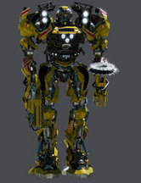  AUTOBOT RATCHET® | 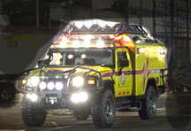  HUMMER® H2®
AUTOBOT RATCHET® serves as the medic to his Autobot brethren. In “TRANSFORMERS,” however, he takes the form of a Hummer® H2®, modified into an ambulance. He is a healer, but a soldier nonetheless. His courage and loyalty are demonstrated time and again.

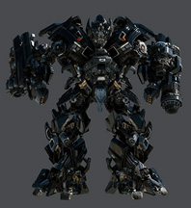  IRONHIDE® | 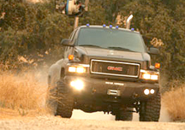  GMC TOPKICK® 6500 pickup truck
IRONHIDE® is a tough hombre, a cowboy who is all action and has been around the universe a few times. One of Optimus Prime®’s oldest friends, he is probably the most battle-scarred of his brethren. He is usually in charge of safekeeping anything or anyone of importance, and acts as Optimus Prime's personal bodyguard. His favorite saying: "High tech circuitry is no replacement for guts."
Gruff, but kind, he shoots a variety of liquids from super-cooled nitrogen to super-heated lead. He has sonar, radar, radio-wave detector. Although he’s the slowest Autobot®, his skin is made of a trithyllium-steel alloy injected with irradiated carbon fibers, giving him immunity to most forms of attack and making him the least vulnerable Autobot.

DECEPTICONS®: The “bad guys” in the TRANSFORMERS race. DECEPTICONS believe in total domination of the universe and the acquisition of power…and they will exploit anyone and anything that stands in their way. The Decepticons exhibit typical gang behavior, and each member’s loyalty is to himself first.

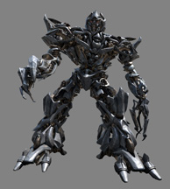  MEGATRON® | 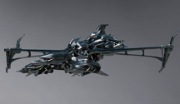  ALIEN JET
MEGATRON® is the ruthless leader of the DECEPTICONS® and the primary villain in the “TRANSFORMERS” saga. His vehicle – a Jet, Tank or Blaster. Megatron is one of the TRANSFORMERS robots, giving him the ability to modify his body's structure into other objects, the original and most common "alternate mode" being a gun.
He was the sworn opponent of Optimus Prime®, leader of the Autobots, when the civil war erupted again.
Eventually, the war drained Cybertron of most of its energy, necessitating that both factions seek out new worlds and new sources of power. Megatron and his elite forces pursued the Autobots' craft (the Ark) in their star cruiser and attacked and boarded the craft, causing it to crash on prehistoric Earth, entombing all on the ship in emergency stasis as it crashed into a dormant volcano.

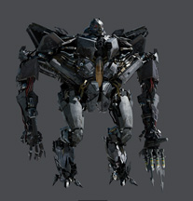  STARSCREAM® | 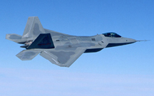  LOCKHEED MARTIN® F-22®  RAPTOR® JET
STARSCREAM®'s intelligence and skill assured him the position of the Decepticons®’ second-in-command. Sly and ruthless but highly capable. Starscream makes no secret of the fact that he wants to replace Megatron as leader of the Decepticons.
The Decepticons left Cybertron following the Autobots®, and crashed into Earth. While departing the Ark and leaving the Autobots for dead, Starscream fired upon the ship, unwittingly causing the Autobots to be reactivated.

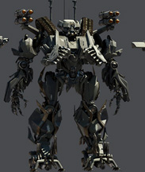  BRAWL™ | 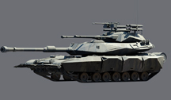  TANK
BRAWL™ is an ornery Decepticon®, one of MEGATRON®’S loyal henchmen, who is always ready for battle. His machine is a tank which has a distinctive three-barrel turret. While Brawl is something of a loudmouth, he is only telling the truth about his abilities. Brawl has an extremely short temper, provoking bursts of uncontrollable fury that render him berserk in battle.
Brawl is built for one thing, and on thing alone – destruction. His programming has been gripped, for as long as he can remember, by a rage so deep and so hot that he feels little else. The only thing that allows him a few moments of happiness is the fury of combat. There is nothing so sweet to him as the thunderous noise of his shells bursting against the armor of a faltering Autobot.®
Brawl is heavily armed, with a Gatling gun, claws and twin missile launchers.

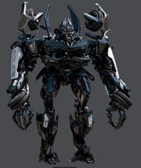  BARRICADE® | 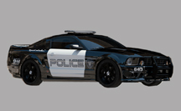  POLICE CAR, SALEEN® S281™
Brawl’s partner, BARRICADE®, is the hunter of the group, using his very human traits to lure us into a trap. He is the scout/hunter, hiding among the humans disguised as a symbol of authority. His hands, which are attached to wheels, can also become spikes and guns come out his hood in vehicle mode.

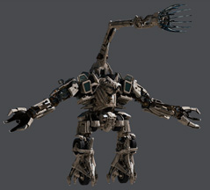  BONECRUSHER® | 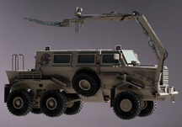  FORCE PROTECTION BUFFALO™ MPCV™  (MINE PROTECTED CLEARANCE VEHICLE)
BONECRUSHER ®, another Constructicon, is one of MEGATRON®’S subservient soldiers, a brawler by nature and specializes in demolitions. He converts into a military armored vehicle and forms Brawl’s left arm.

SKORPONOK®, Mechanical Scorpion | SYMBIOTE (smaller robot  deployed by BLACKOUT)
SKORPONOK® is a vehicle who moves through his environment stealthily. Skorponok is deployed from Blackout® and can fire rockets.

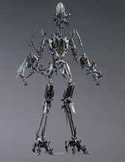  DECEPTICON FRENZY™ | 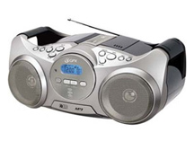  BOOM BOX
DECEPTICON FRENZY™ is one the smallest DECEPTICONS® and is often seen converted into an everyday gadget (e.g., boom box) for purposes of spying on humans. He has multiple alternate modes, one of which is a car CD player, and the other being the stereo seen in the new trailer.

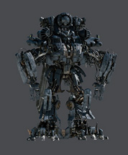  BLACKOUT® (Formerly VORTEX) | 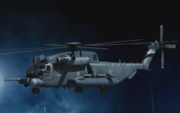  SIKORSKY MH-53  JM PAVE LOW™ III/IV Helicopter
BLACKOUT® changes into a MH-53 JM Pave Low™ III/IV Helicopter. Blackout is the largest Decepticon®, transporting the other group members, and he has the ability to disrupt mechanical devices via EMP.
Blackout is said to have a cage that holds Skorponok®, which is where the Soundwave connection was first made.
In “TRANSFORMERS,” Blackout and his partner Skorponok attack the Soccent Operations Base in Qatar.

